Website Project Proposal: Sihle's Foundation
1. Organization Overview
Sihle's Foundation, founded in 2023, addresses food insecurity and social isolation through a food bank, community meals, and befriending services for the elderly.
Mission: To nourish our community and foster belonging.
Vision: A community where no one goes hungry and everyone feels valued.
Target audience: Individuals/families facing food poverty, isolated elderly, volunteers, donors, and local businesses.
2. Website Goals and Objectives
Goals: Increase online donations by 68% within year one; build trust and transparency.
KPIs: Unique visitors, page views, session duration; donation conversion rate and total value; volunteer applications; service page visits; newsletter sign-ups.
3. Current Website Analysis
Strengths: Positive local reputation, basic contact information.
Weaknesses: Static "brochure" site, not mobile-responsive, confusing navigation, lacks clear calls-to-action, poor SEO, insecure donation process.
Improvements: Mobile-friendly design, intuitive navigation, prominent CTAs for donations and volunteering, mission-driven content demonstrating impact.
4. Proposed Features and Functionality
Pages: Homepage, About Us, Our Services, Contact Us, Enquiries.
Functionality: Mobile-responsive design, SEO optimization, accessibility features (screen-reader compatibility, keyboard navigation, color contrast), social media integration.
5. Design and User Experience
Aesthetic: Clean, modern, compassionate with warm imagery.
Colors: Deep Navy (#2C3E50) and Warm Orange (#E67E22) CTAs on white/off-white backgrounds.
Typography: Open Sans (body) and Merriweather (headings).
UX: Simple navigation (Home, About, Our Services, Contact, Enquiry), consistent layout, authentic visuals.
5.1 Wireframe: Homepage (Low Fidelity)
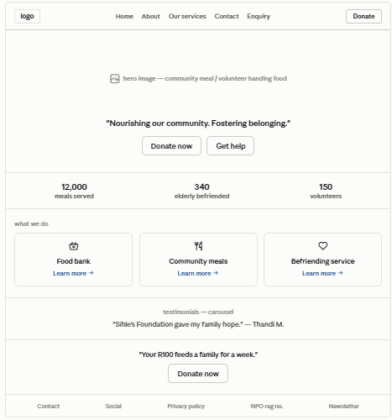
5.2 Wireframe — Mobile View (375px)
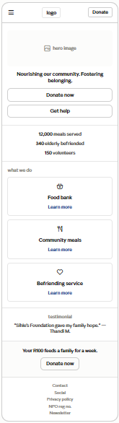
5.3 Layout & UX Notes
- F-pattern reading flow for scanability.
- Sticky header with persistent "Donate" button - always one click from conversion.
- Colour contrast ratio ≥ 4.5:1 (Warm Orange #E67E22 on white passes WCAG AA for large text; use Deep Navy for body text to ensure compliance).
- Keyboard navigation order: Logo → Nav → Donate → Hero CTAs → Sections.
- Alt text required on all imagery (screen-reader compatibility, per W3C WAI 2026).
6. Technical Requirements
Hosting: Reliable provider with SSL certificate.
Domain: sihlesfoundation.co.za
CMS: WordPress or Access Raise.
Technologies: HTML, CSS, JavaScript (front-end); CMS back-end; MySQL database.
7. Timeline and Milestones (12 weeks)
Weeks 1-2: Discovery & Planning - finalize sitemap.
Weeks 3-5: Design & Prototype - approve high-fidelity mockups.
Weeks 6-10: Development - functional demo.
Week 11: Testing & Review - final approval.
Week 12: Launch - site live.
8. Budget
8.1 One-Time Costs
Item | Cost (ZAR) | Justification / Source
UI/UX Design | R15,000 – R30,000 | Based on average South African freelance web-designer rates for a 5–8 page custom design (rates of R250–R450/hr × 40–60 hrs).
Development | R30,000 – R60,000 | WordPress custom theme development; local agency quotes range R25k–R70k for brochure + donation functionality.
Subtotal | R45,000 – R90,000
8.2 Annual Recurring Costs
Item | Cost (ZAR) | Justification / Source
Domain (.co.za) | R150 | Typical ZA registry annual fee (e.g., Xneelo, Afrihost).
Hosting | R4,000 – R10,000 | Shared WordPress hosting with SSL support; R350–R850/month tier.
SSL Certificate | R0 – R2,000 | Free Let's Encrypt often included; premium cert optional.
Maintenance | R5,000 – R15,000 | Monthly updates, backups, security patching, content edits (R400–R1,250/month).
Subtotal | R9,000 – R27,000

8.3 Total Year-One Cost of Ownership
R54,000 – R117,000
8.4 Payment & Donation Processing
- PayFast / Yoco / SnapScan transaction fees (~2.5–3.5% per donation) — variable, not included above.
- Google for Nonprofits (n.d.) provides free ad grants and Google Workspace discounts, reducing marketing costs.
9. References
Bond, Schoeneck & King PLLC, 2026. Available at: https://www.bsk.com/... (Accessed: 12 August 2026).
Google for Nonprofits, n.d. Available at: https://support.google.com/nonprofits/... (Accessed: 10 August 2026).
Kim, L., 2025. User Experience for Nonprofits. 3rd edn. New York: UX Press.
Mozilla Developer Network, 2026. Available at: https://developer.mozilla.org/... (Accessed: 12 August 2026).
Smith, J. and Patel, R., 2025. Journal of Digital Philanthropy, 14(2), pp. 45-62.
The Access Group, 2026. Available at: https://www.theaccessgroup.com/... (Accessed: 10 August 2026).
W3C WAI, 2026. Available at: https://www.w3.org/WAI/... (Accessed: 12 August 2026).
Wired Impact, 2026. Available at: https://wiredimpact.com/... (Accessed: 11 August 2026).
WordPress Foundation, 2026. Available at: https://wordpress.org/ (Accessed: 12 August 2026).

